# Charts Description

1. Line Chart – Total Funding INR by Year  
   A line chart is ideal for showing trends over time. It helps visualize how funding changed across years.  
   It relates Year to Total Funding (INR)—showing funding growth and decline over time.

* Funding peaked in 2017 (₹380.25bn).
* There was a sharp decline by 2020 (₹14.12bn), indicating possibly market disruptions.
* Initial dip in 2016 and a rebound later shows investment volatility.

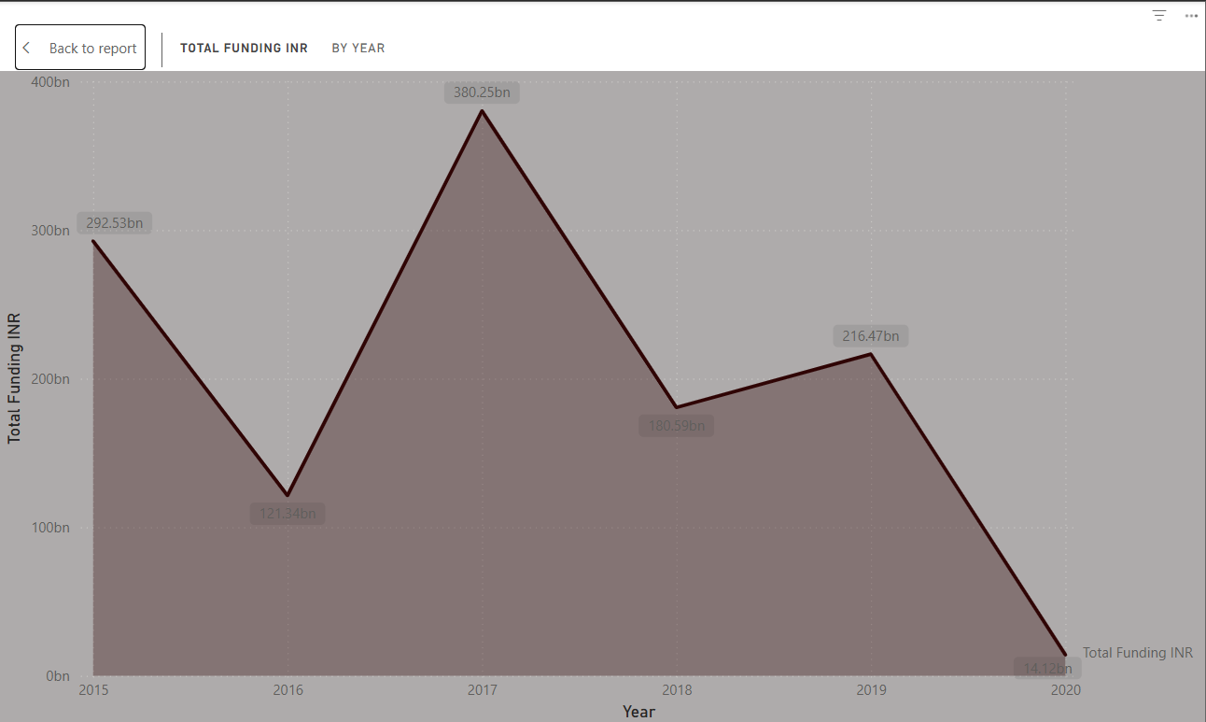

1. Pie Chart – Number of Investments by Industry Vertical  
   A pie chart provides a clear visual breakdown of proportions between categories.  
   It compares the number of investments across different industry verticals.

* Consumer Internet (28.86%) dominates investment.
* Followed by Technology (15.54%) and Ecommerce (8.99%).
* Long tail of small verticals indicates diversification of sectors.

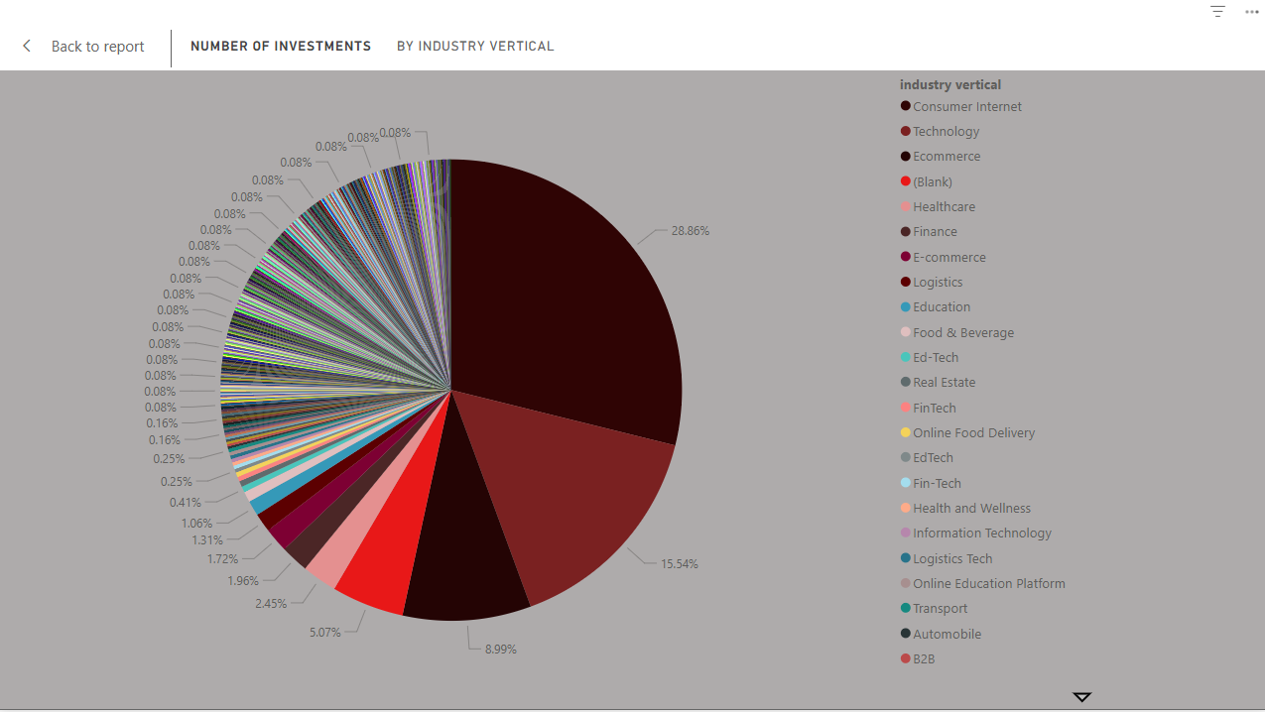

1. Stacked Column Chart – Average Funding and Latest Year Funding by Investment Type  
   Used to compare multiple values (average vs. latest) across a single dimension (investment types).  
   It compares average funding and the latest year funding for each investment type.

* Private Equity and Single Venture have the highest average and latest funding.
* Many smaller types show minimal recent activity.
* Useful to identify consistent high-value funding routes.

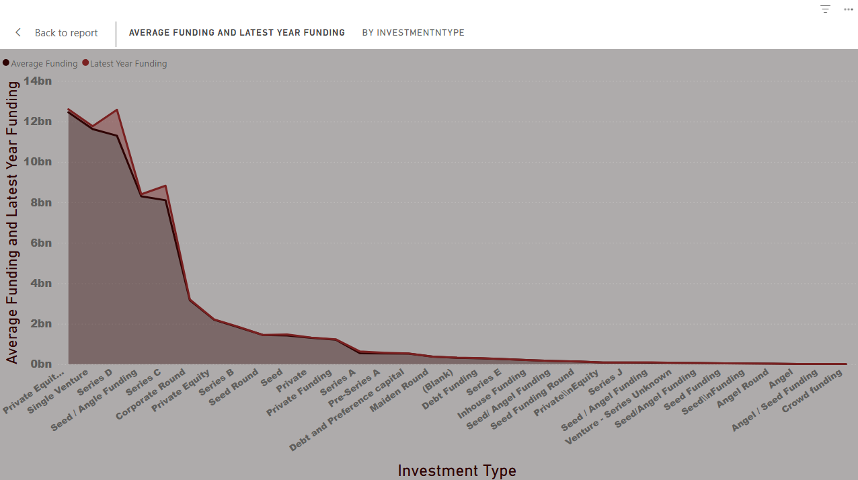

1. Decomposition Tree – Funding by Industry, City, and Year  
   A decomposition tree allows dynamic drill-down and root cause analysis of totals.  
   It breaks down Total Funding by Industry → City → Year.

* Ecommerce in Bangalore (₹230bn) in 2017 is the top contributor.
* Useful for identifying geographic and temporal concentration.

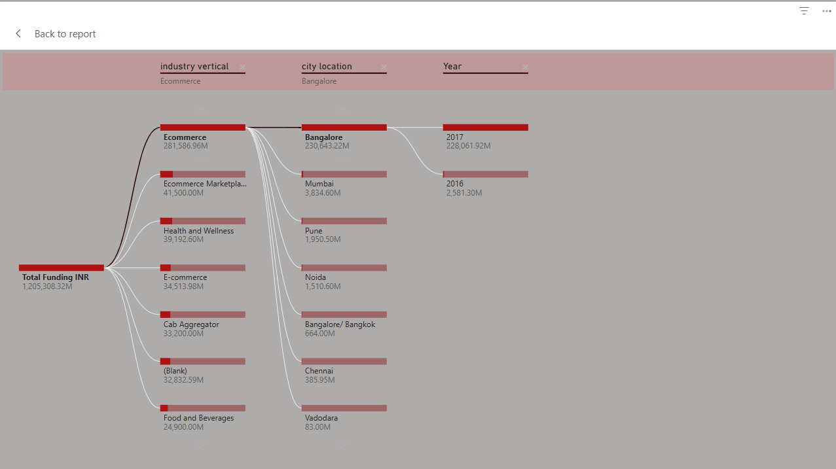

1. Donut Chart – Number of Investments by Investment Type  
   Donut charts highlight proportions with a central focus metric.  
   It shows which investment types are most common in terms of number of deals.

* Private Equity (44.89%) and Seed Funding (42.68%) dominate the landscape.
* This suggests early-stage and growth-stage funding are the most frequent.

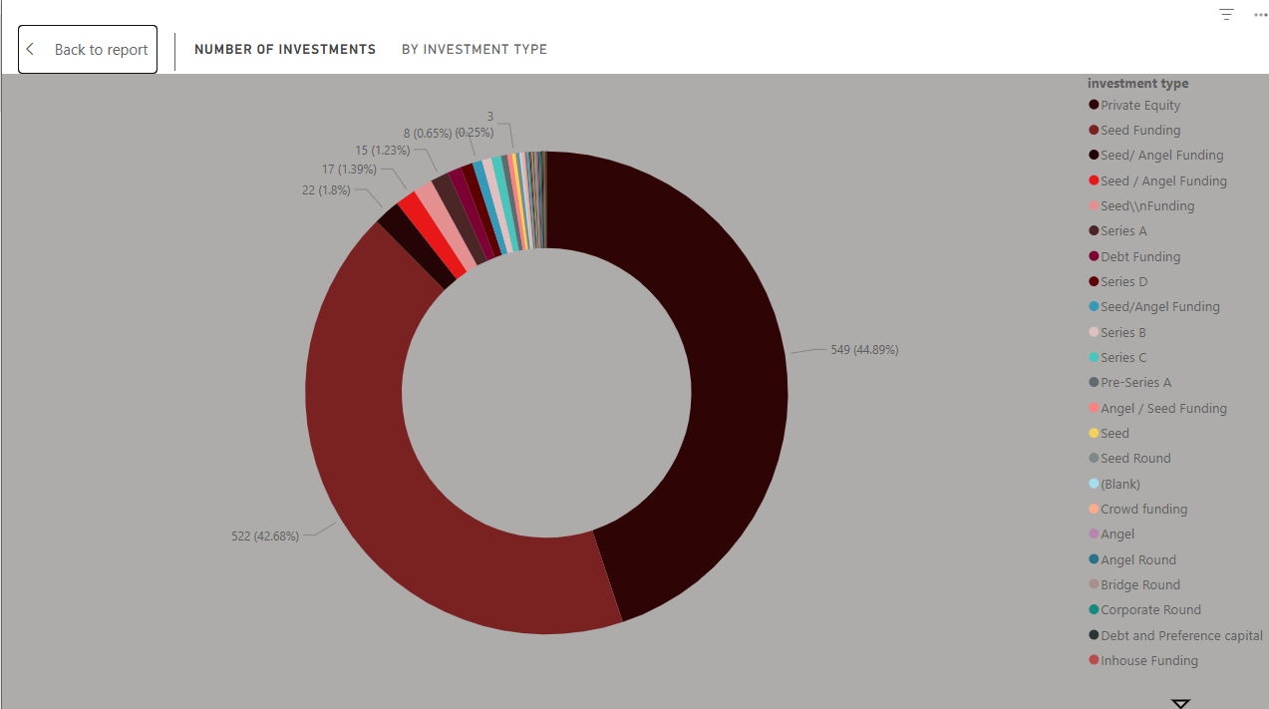

1. Line + Column Chart – Total Funding and Number of Investments by Startup  
   Dual-axis charts are best to visualize two metrics across the same category.  
   Shows Startup name vs both Total Funding (columns) and Number of Investments (line).

* Flipkart leads with ₹212bn and high investment count.
* Some startups have high funding but fewer rounds (e.g., Udaan, Snapdeal).
* Reveals funding concentration.

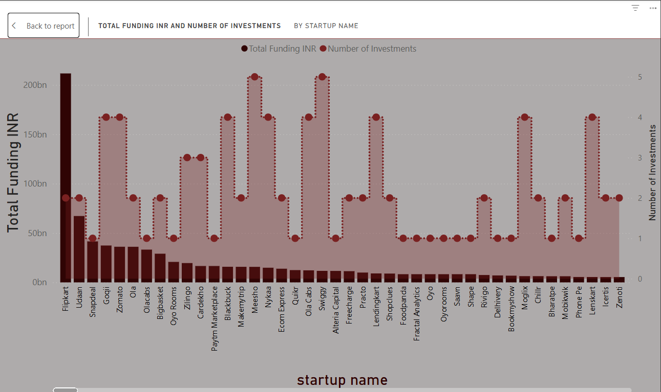

1. Clustered Bar Chart – Total Funding by Startup  
   A simple horizontal bar chart provides a clear comparison of totals.  
   Compares startups by total amount raised.

* Easy-to-read format to identify top-funded startups.
* Flipkart, Udaan, Snapdeal dominate the landscape.

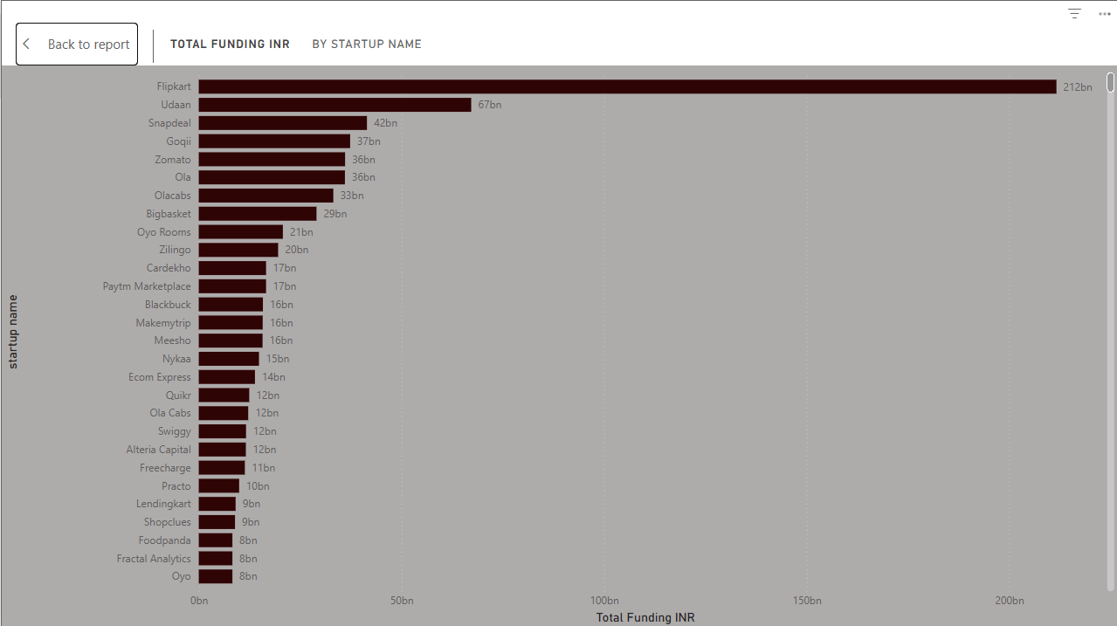

1. Dashboard – Overview of Key Metrics  
   Dashboards summarize KPIs and visuals in one page for storytelling and executive overview.  
   Integrates all charts and metrics: totals, averages, industry and city trends.

* Total funding: ₹1.21T, 1223 investments, 1065 startups.
* Consumer Internet and Private Equity dominate.
* Interactive filters for year, vertical, and location.

